E-Commerce Sales &
Customer Behavior Analysis
Brazilian E-Commerce Public Dataset by Olist

Tools Used: Excel • MySQL • Power BI
Dataset Source: Kaggle – Olist Brazilian E-Commerce Public Dataset
Data Coverage: September 2016 – September 2018

Table of Contents
1. Project Objective 2
2. Dataset Overview 2
2.1 Dataset Summary 2
3. Tools & Technologies Used 3
4. Data Cleaning & Preparation 3
4.1 Steps I Performed 3
4.2 Data Limitations I Noted 4
5. Analytical Challenges & Discoveries 4
5.1 The Customer ID Problem 4
5.2 The 2016 Revenue Mystery 5
5.3 The Null Timestamp Question 5
6. Key Insights 5
6.1 Revenue Grew Strongly, But the 2016 Numbers Are Misleading 5
6.2 Health & Beauty Carries a Disproportionate Share of Revenue 5
6.3 Sao Paulo Dominates, Everyone Else Is Far Behind 6
6.4 The Retention Rate Is the Most Important Number in This Dataset 6
6.5 Delivery Time Is a Baseline, Not a Verdict 6
7. KPI Summary 6
8. Dashboard Development 7
8.1 Executive Sales Dashboard 7
8.2 Business Insights Dashboard 7
9. Business Recommendations 8
9.1 Make Customer Retention the Top Priority 8
9.2 Investigate Delivery and Its Impact on Satisfaction 8
9.3 Reduce Category Concentration 9
9.4 Expand Beyond Sao Paulo 9
9.5 Build a Seller Performance View 9
10. What I Would Explore Next 9
11. Conclusion 9
Appendix: Key SQL Queries 10
Monthly Revenue 10
Customer Retention Rate (using customer_unique_id) 10
Average Delivery Time 10

1. Project Objective
I worked on this project to build real, hands-on experience with an end-to-end data analysis workflow. I wanted to go beyond tutorials and work with a messy, real-world dataset that required actual cleaning decisions, genuine SQL problem-solving, and meaningful business interpretation.

The Olist dataset appealed to me because it covers a real Brazilian e-commerce business with millions of rows spread across 9 relational tables — the kind of data structure you encounter in actual business environments. My specific goals were:
- Understand how revenue and order volume changed over time
- Find which product categories and cities drove the most sales
- Measure customer retention and understand repeat purchase behavior
- Calculate core KPIs like Average Order Value and delivery performance
- Build a Power BI dashboard that communicates findings clearly to a non-technical audience

2. Dataset Overview
The dataset is a public Brazilian e-commerce dataset released by Olist on Kaggle. It contains real transactional data from 2016 to 2018 across 9 relational tables. My first task was simply understanding how these tables connected to each other before touching any analysis.

2.1 Dataset Summary
Dataset | Rows | Columns | Null Values / Notes
olist_orders_dataset | 99,442 | 8 | Timestamp nulls found: 1,784 (purchase), 161 (approved), 1,786 (carrier), 2,966 (customer delivery). Estimated delivery has zero nulls.
olist_customers_dataset | 99,442 | 5 | No blanks. zip_code_prefix has mixed text/number formats.
olist_geolocation_dataset | 1,000,165 | 5 | No blanks. Largest table in the dataset.
olist_order_items_dataset | 112,651 | 7 | No blanks. Contains price and freight values per item.
olist_order_payments_dataset | 103,887 | 5 | No blanks. Multiple payment types and installment options.
olist_order_reviews_dataset | 99,225 | 7 | review_comment_title: 87,659 nulls. review_comment_message: 58,257 nulls.
olist_products_dataset | 32,952 | 9 | 611 nulls in category/name/desc/photo columns. Dimension fields have 2 nulls each.
olist_sellers_dataset | 3,096 | 4 | seller_zip_code_prefix stored as mixed text/number.
product_category_name_translation | 72 | 2 | Only 72 of 32,952 product categories have English translations.

3. Tools & Technologies Used

Excel | Used for initial inspection before loading into SQL — checking column formats, spotting blanks using Sort by Color, and using UNIQUE() to list distinct values like order_status.

MySQL | Primary tool for data cleaning, type corrections, JOIN validation, and all analytical queries across revenue, retention, delivery, categories, and geography.

Power BI | Built two interactive dashboards — an Executive Sales view and a Business Insights view — with KPI cards, trend charts, category breakdowns, and geographic maps.

4. Data Cleaning & Preparation
Before running any analysis, I spent time understanding the data and making sure it was reliable. A few things required decisions, not just fixes.

4.1 Steps I Performed
- Imported all 9 tables into MySQL and verified row counts matched the source files.
- Used JOINs across all tables to verify key consistency before analysis — this gave me confidence that the data was structurally sound.
- Identified null values in every column using Excel (Sort by Color) and documented them in the dataset summary table above.
- Standardized zip_code_prefix in both the customers and sellers tables, where values were stored inconsistently as text and numbers.
- Joined the product_category_name_translation table to add English labels where available.
- Built a master joined dataset combining orders, customers, items, payments, products, sellers, and geolocation for unified reporting.

4.2 Data Limitations I Noted
- The 2016 data only covers September, October, and December — three months with very low volume. This is a data coverage issue, not a business problem.
- September 2018 shows only one order, which is another coverage cutoff, not a real business event.
- The review comments table has very high null rates (87,000+ in titles), so I could not do any meaningful sentiment analysis on text feedback.
- Only 72 product categories are translated to English out of 32,952 product entries, so most category analysis used the original Portuguese names.

5. Analytical Challenges & Discoveries
This section is important to me because the most valuable learning in this project came from moments where something did not make sense, and I had to figure out why. I want to document those moments honestly.

5.1 The Customer ID Problem
When I first ran my repeat customer analysis, the result showed zero repeat customers. None. I knew that could not be right — any real e-commerce platform has returning customers.

My first thought: Is the service that bad? All locations can’t be bad, right? This can’t be right.

After investigating, I found the issue: the dataset assigns a brand new customer_id for every single order. So every customer looks like a new customer in the data, even if they have ordered 10 times. The real identifier is customer_unique_id, which stays consistent across a person’s orders.

Once I switched to customer_unique_id, I found that some customers had made 2 or more purchases. This led me to the correct retention rate of 3.05%. It’s a small but critical distinction, and getting it wrong would have produced completely misleading results.

Key lesson: Always understand what a column actually represents before using it in analysis. ‘customer_id’ and ‘customer_unique_id’ look similar but measure completely different things.

5.2 The 2016 Revenue Mystery
When I first looked at the monthly revenue chart, 2016 looked disastrous. Revenue was near zero for most months, and December 2016 had just one order with R$10.90 in revenue. My immediate questions were: Did the store close? Was this a holiday shutdown? Did I lose data during import?

I went back and verified my JOINs — the data was consistent across tables. Then I looked at the actual date range in the dataset and realized: 2016 only has data for September, October, and December. It is an incomplete year. The platform was likely in its early launch phase, not failing.

This taught me not to jump to business conclusions before confirming data coverage. The data told a story, but not the one I initially assumed.

5.3 The Null Timestamp Question
I noticed that order_approved_at, order_delivered_carrier_date, and order_delivered_customer_date all had thousands of null values, while order_estimated_delivery_date had none. My first reaction was that something went wrong in the import.

But it actually makes sense: an estimated delivery date is set at the moment of purchase for every order. The actual timestamps only get filled in as the order progresses through fulfillment. Canceled, processing, or unavailable orders never reach those stages, so those fields stay null. The data was correct — I just had to think through the order lifecycle.

6. Key Insights
These are the findings that I believe matter most from the analysis. I have tried to explain not just what the numbers say, but what they actually mean for the business.

6.1 Revenue Grew Strongly, But the 2016 Numbers Are Misleading
Revenue increased significantly from 2017 into 2018, which shows real business growth. However, 2016 should not be used for year-over-year comparisons because the dataset only covers 3 months of that year.

6.2 Health & Beauty Carries a Disproportionate Share of Revenue
The Beleza_saude (Health & Beauty) category generated R$1,258,681. The next categories are significantly lower. At the bottom, Seguros_e_servicos made just R$283 across the entire period. This level of concentration is a risk — if demand in Health & Beauty drops, it would have an outsized impact on the whole business.

6.3 Sao Paulo Dominates, Everyone Else Is Far Behind
Sao Paulo generated R$1,914,924 and the gap between it and the next city is enormous. Morada Nova sits at the other end with R$1,355. Brazil has many large cities with substantial purchasing power that are barely represented in this data. That looks like an expansion opportunity.

6.4 The Retention Rate Is the Most Important Number in This Dataset
Only 3.05% of customers came back for a second purchase. That is the finding I keep coming back to. It means that for every 100 customers the business acquires, 97 of them never return. A business running at 3% retention is working extremely hard just to stay flat — it needs to constantly attract new buyers to replace the ones that never come back.

6.5 Delivery Time Is a Baseline, Not a Verdict
The average delivery time is 12.5 days from purchase to customer. I flagged this as something worth watching. A natural next step would be to correlate delivery time with review scores (1–5 stars) to test whether slower deliveries produce worse ratings.

7. KPI Summary
Note: All monetary values are in Brazilian Reais (R$ / BRL), the official currency of Brazil.

KPI Metric | Value | What it told me
Total Revenue | R$13.59M | Strong overall business, but growth was uneven month to month
Total Orders | 99,441 | Healthy volume across ~2 years of real data
Unique Customers | 95K | Almost 1:1 with orders — confirmed the low repeat rate
Customer Retention Rate | ~3.05% | The finding that surprised me most — and the biggest opportunity
Average Order Value (AOV) | R$137.75 | Stable throughout — customers spend consistently
Avg. Delivery Time | 12.5 days | A benchmark I want to explore further against review scores
Top Revenue Category | Beleza_saude | Health & Beauty drives the highest revenue of all categories
Top Revenue City | Sao Paulo – R$1.91M | Way ahead of every other city — too concentrated

8. Dashboard Development
I built two Power BI dashboards to present the findings in a format that does not require someone to read SQL results. Both dashboards are shown below.

8.1 Executive Sales Dashboard
Designed for a quick, high-level read of business performance. It includes KPI cards for total revenue, orders, customers, and AOV; a monthly revenue trend line; order volume by month; top product categories by revenue; and a geographic map of sales across Brazil.

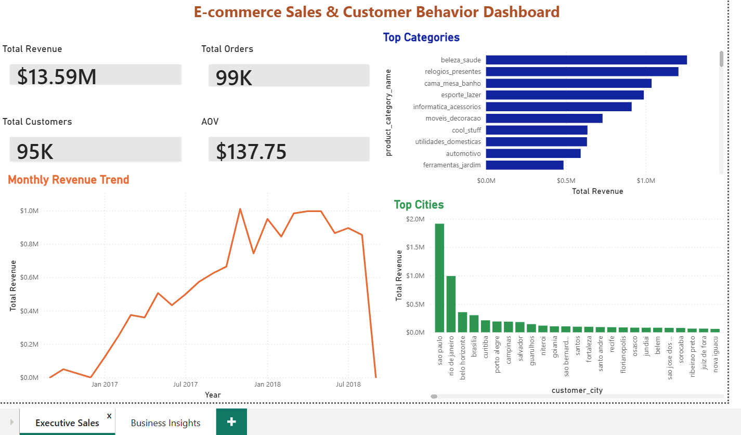
Figure 1: Executive Sales Dashboard — Power BI

8.2 Business Insights Dashboard
Goes deeper into the analytical findings. It includes the customer retention rate, revenue contribution by category, top cities breakdown, monthly growth rate, and key business recommendations built directly into the dashboard.

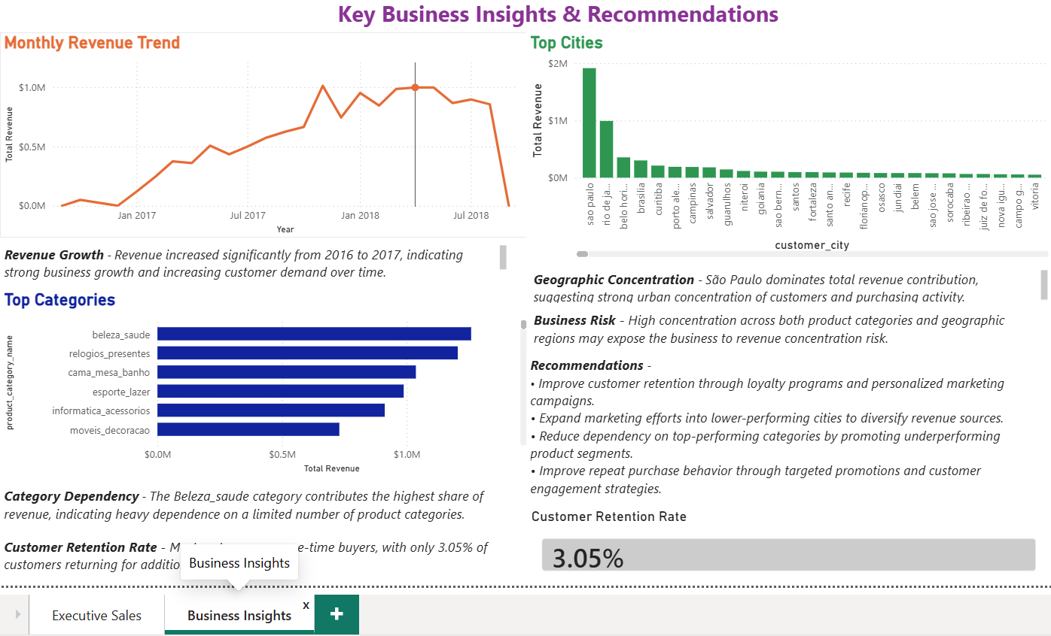
Figure 2: Business Insights Dashboard — Power BI

9. Business Recommendations
These recommendations come directly from what the data showed. I have tried to be specific about the reasoning rather than just listing generic suggestions.

9.1 Make Customer Retention the Top Priority
A 3.05% retention rate is the clearest problem in this dataset. The business is spending money to acquire customers and then losing almost all of them. Even moving from 3% to 6% retention would meaningfully reduce how much the business needs to spend on new customer acquisition. A loyalty program, a follow-up email after the first purchase, or a discount on the second order are low-cost starting points.

9.2 Investigate Delivery and Its Impact on Satisfaction
The 12.5-day average delivery is a flag, not a confirmed problem. I would want to join the delivery data with review scores to see whether late deliveries correlate with 1 or 2-star ratings. If they do, investing in faster fulfillment in high-density areas like Sao Paulo would be an easy win for satisfaction and possibly retention.

9.3 Reduce Category Concentration
Having the majority of revenue in a single category creates concentration risk. The mid-tier categories clearly have demand but may lack visibility or seller support. Promoting them through targeted campaigns or onboarding more sellers in underperforming categories would help diversify the revenue base.

9.4 Expand Beyond Sao Paulo
Brazil has major cities like Rio de Janeiro, Belo Horizonte, Curitiba, and Manaus that are underrepresented in this data. Geographic expansion would directly reduce the concentration risk and open up large untapped markets.

9.5 Build a Seller Performance View
The seller dataset has 3,096 sellers, and I did not analyze it independently in this project. A seller-level breakdown of revenue, delivery speed, and average review score would identify which sellers are driving quality and which are dragging it down. That is a logical next step for this analysis.

10. What I Would Explore Next
There are several directions I did not get to in this project that I think would add significant value:
- Correlate delivery time with review scores to test whether logistics performance drives negative ratings
- Run a seller-level analysis to find top and bottom performers across revenue, delivery, and reviews
- Analyze payment types and installment usage — the payments table captures this but I did not use it
- Apply seasonal decomposition to the monthly growth rate to separate true growth from cyclical patterns
- Segment customers by purchase frequency and AOV to identify high-value segments worth more attention
- Extend the product category translation table to cover all 32,952 categories for cleaner reporting

11. Conclusion
This project gave me real experience with a full data analysis workflow — from messy raw tables all the way to a dashboard a business stakeholder could actually use.

The most important technical lesson for me was the customer_id vs. customer_unique_id problem. It was a reminder that understanding your data model is not optional — one wrong assumption at the column level can invalidate an entire analysis. I caught it because the result (zero repeat customers) made no logical sense, which pushed me to dig deeper.

The most important business finding is the 3.05% retention rate. It is a single number that tells a lot about the health of a business and where its energy should go. The analysis did not just confirm what was obvious — it surfaced something genuinely worth acting on.

Overall, this project strengthened my confidence in SQL, taught me to question my own results before accepting them, and showed me how to turn a large, messy dataset into a focused, readable story. There is more to explore in this dataset, and I documented those directions in Section 10.

Appendix: Key SQL Queries
These are some of the core queries I wrote for this project.

Monthly Revenue
SELECT DATE_FORMAT(o.order_purchase_timestamp, '%Y-%m') AS month,
ROUND(SUM(p.payment_value), 2) AS total_revenue
FROM olist_orders o
JOIN olist_order_payments p ON o.order_id = p.order_id
GROUP BY month ORDER BY month;

Customer Retention Rate (using customer_unique_id)
SELECT ROUND(COUNT(CASE WHEN order_count > 1 THEN 1 END) * 100.0 / COUNT(*), 5) AS retention_rate
FROM (
SELECT c.customer_unique_id, COUNT(DISTINCT o.order_id) AS order_count
FROM olist_orders o JOIN olist_customers c ON o.customer_id = c.customer_id
GROUP BY c.customer_unique_id) AS sub;

Average Delivery Time
SELECT AVG(DATEDIFF(order_delivered_customer_date, order_purchase_timestamp)) AS avg_delivery_days FROM olist_orders WHERE order_delivered_customer_date IS NOT NULL;

